OSAGE NATION SCIENCE FAIR
WRANGLER
BASKETBALL
Elementary basketball 1-4 are playing a short schedule. These little ballers have played a couple games already this year. They are gearing up to play in the Osage Hills Tournament the week of February 5th. This is a 3rd and 4th grade tournament and we have a lot of 1st and 2nd graders on the team, but they are a lot of fun to watch.
JH Basketball ORES
The 7th and 8th graders are finishing up their season with the ORES playoffs. This is a great time for the kids working their way back to the state tournament. If you are interested in watching either tournament, check the school website.

WRANGLER WRITE UP
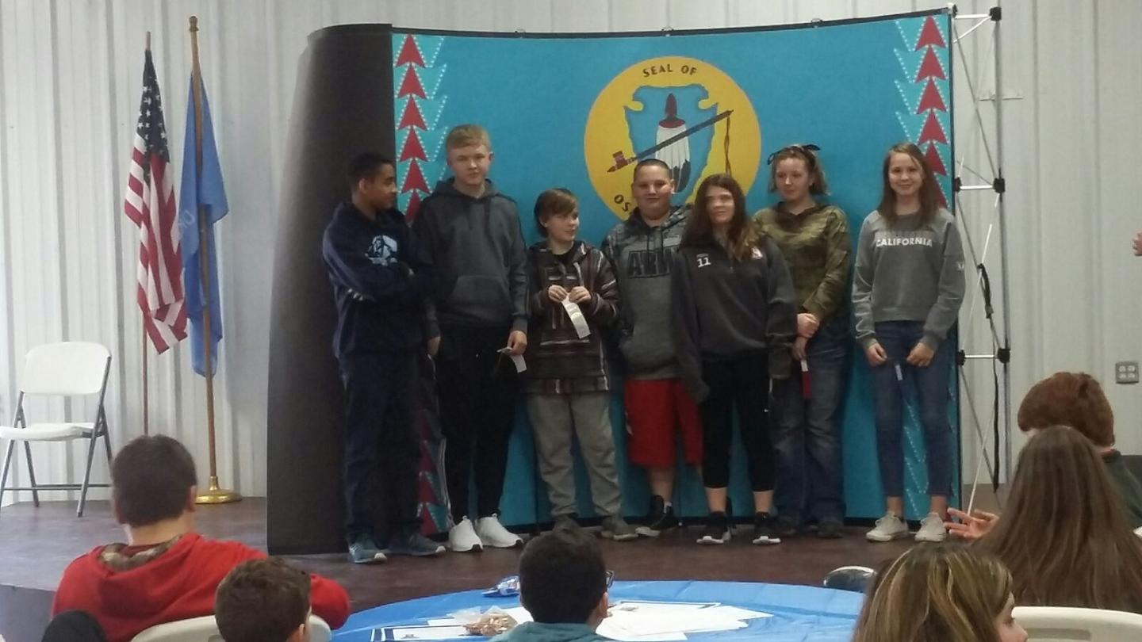
“IT’S NOT ABOUT HAVING THE SKILL TO DO SOMETHING. IT’S ABOUT HAVING THE WILL, DESIRE, AND COMMITMENT TO BE YOUR BEST."

On Thursday, September 25th, the 7th and 8th graders loaded up their projects and went to the Osage Nation STEAM Science Fair at the Pawhuska Fairgrounds. Charlee and Trinity had been working on a cookie project testing the effectiveness of baking soda versus baking powder. Unfortunately, Charlee got sick and so talking to the judges was all on Trinity. Bonus points were awarded for including the Osage language, and luckily Trinity just happened to know some Osage words. She did great, and she even brought home a first place ribbon for their project in the category of Chemistry.
There was another category they did specifically for partners. All 3 groups had Chemistry projects. Ty, Max, and Alan won 3rd in their category with self-inflating balloons. Anthony and Baylee won 2nd place with their self-inflating balloon project. Taylor and Payge brought home a 1st place ribbon with their project testing what materials best kept fruits from browning.
This was the 1st year the 7th and 8th grade had participated in the Science Fair, and they can’t wait for next year. They learned lots of cool stuff, and they are anxious to do more Science!

AWARE GRANT
UPCOMING EVENTS
- February 5 ORES Basketball Playoffs Begin
- February 9 Valentine’s Grams Due
- February 13 Parent Breakfast Reading With Children
- February 14 Valentine’s Day Parties
- February 19 No School

Happy Valentine’s Day
We are currently in the second year of implementing Oklahoma Tiered Intervention Systems of Support for behavior and academics.
Oklahoma Tiered Intervention Systems of Support (OTISS) is a Multi-Tiered Systems of Support (MTSS) model for identifying and intervening upon student academic and behavioral difficulties.
The OTISS framework cohesively blends together academic intervention models (i.e., Response to Intervention) and behavior intervention models (i.e., Positive Behavior Interventions and Supports). The primary goal of OTISS is to improve student achievement through matching research-based interventions to every student’s instructional level and then monitoring the student’s response to increasingly intensified interventions as needed.

WHY OTISS?

It is imperative we recognize the challenges inherent in meeting the diverse needs of Oklahoma students. The rigorous framework for student success established through OTISS ensures all students are provided timely and appropriate interventions as needed. Schools implementing OTISS with fidelity will see improvements in school climate, instructional quality, and student outcomes.

